**Godavari College Of Engineering, Jalgaon.**

**Subject Name:** Data Structure **Teacher Name:** Prof.S.S.Shete

**Practical No**. : 1 **Date:**

**Class: S**.E **Roll No:**

**Title:**  Write a program to implement stack using arrays.

**Aim:** To implement stack using arrays.

**Theory:**

Stack is a linear data structure which follows a particular order in which the operations are performed. The order may be LIFO(Last In First Out) or FILO(First In Last Out).

**Basic operations are performed in the stack:**

* Push: Adds an item in the stack. If the stack is full, then it is said to be an Overflow condition.
* Pop: Removes an item from the stack. The items are popped in the reversed order in which they are pushed. If the stack is empty, then it is said to be an Underflow condition.
* Peek or Top: Returns top element of stack.
* IsEmpty: Returns true if stack is empty, else

**Program:-**

#include<stdio.h>

int stack[100],choice,n,top,x,i;

void push();

void pop();

void display();

int main()

{

clrscr();

top=-1;

printf("\n Enter the size of STACK[MAX=100]:");

scanf("%d",&n);

printf("\n\t STACK OPERATIONS USING ARRAY");

printf("\n----------------------------------------------------------------");

printf("\n\t 1.PUSH\n\t 2.POP\n\t 3.DISPLAY\n\t 4.EXIT");

rep:

printf("\n Enter the Choice:");

scanf("%d",&choice);

switch(choice)

{

case 1:

push();

break;

case 2:

pop();

break;

case 3:

display();

break;

case 4:

printf("\n\t EXIT POINT ");

break;

default:

printf ("\n\t Please Enter a Valid Choice(1/2/3/4)");

}

if(choice!=4)

{

goto rep;

}

return 0;

}

void push()

{

if(top>=n-1)

{

printf("\n\tSTACK is over flow");

}

else

{

printf(" Enter a value to be pushed:");

scanf("%d",&x);

top++;

stack[top]=x;

}

}

void pop()

{

if(top<=-1)

{

printf("\n\t Stack is under flow");

}

else

{

printf("\n\t The popped elements is %d",stack[top]);

top--;

}

}

void display()

{

if(top>=0)

{

printf("\n The elements in STACK \n");

for(i=top; i>=0; i--)

{

printf("\n%d",stack[i]);

printf("\n Press Next Choice");

}

else

{

printf("\n The STACK is empty");

}

}

**Output:**

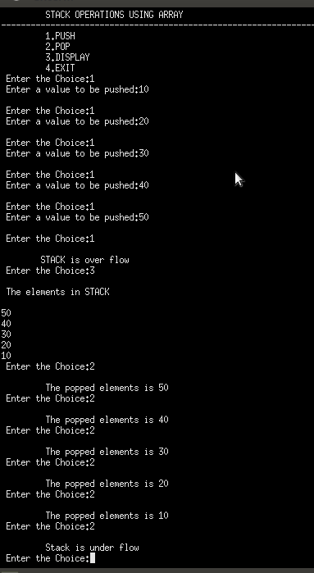

**Conclusion:-**